Figure: Urban built-up area in select Indian cities between 1990 and 2014, extracted from the global human settlement (GHS) layer of landsat imagery (Pesaresi et al., 2016)
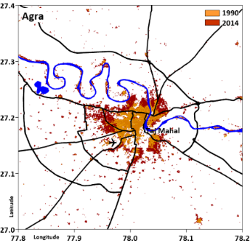 | 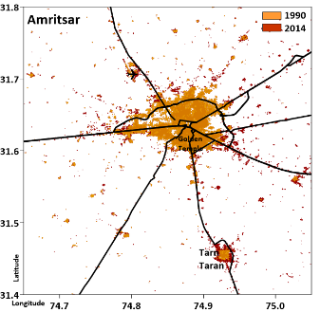 | 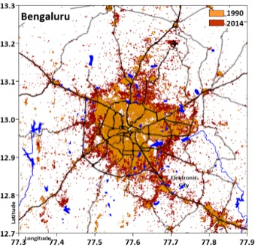 | 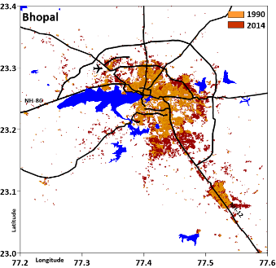 | 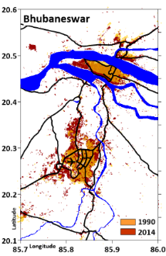
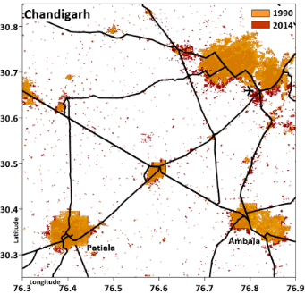 | 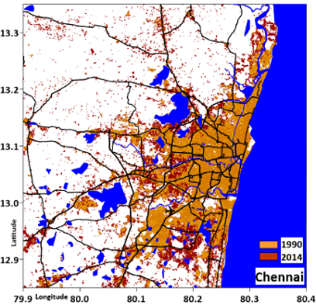 | 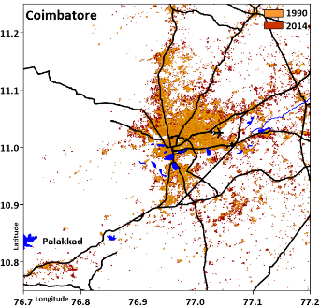 | 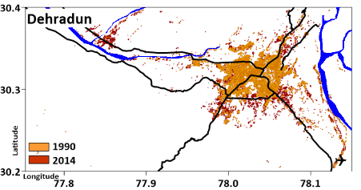 | 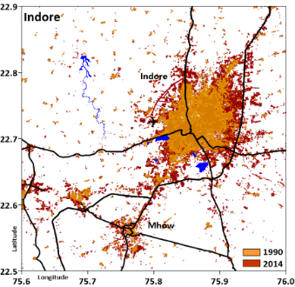
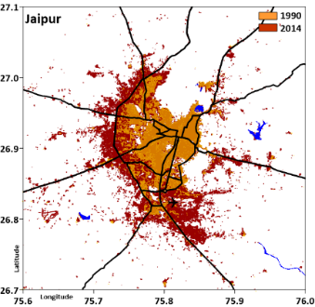 | 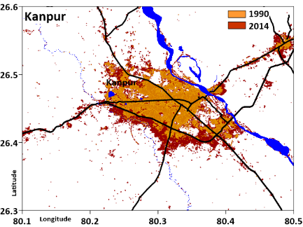 | 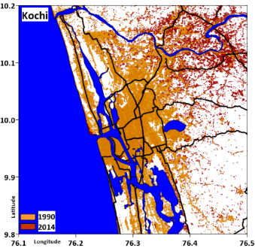 | 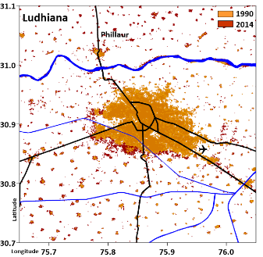 | 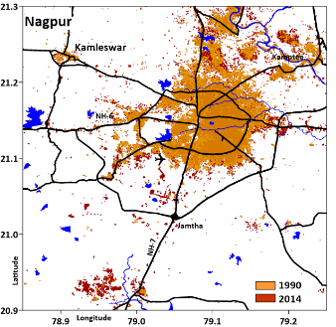
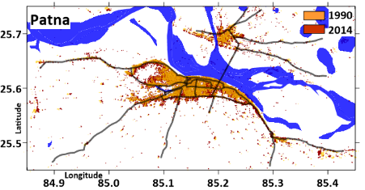 | 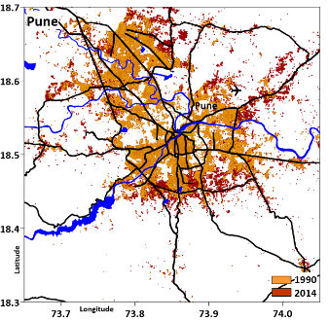 | 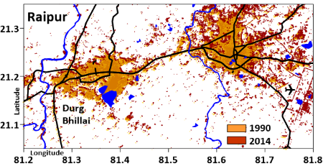 | 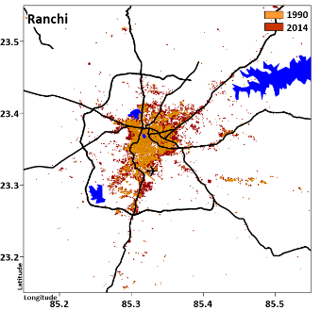 | 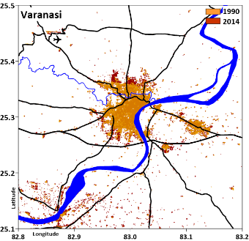

Figure: Projected annual PM_{2.5} emissions (in tons/year) between 2015 and 2030 for 20 Indian cities under the business as usual scenario (RESI = cooking, heating, and lighting; TRAN = road, rail, shipping, and aviation; DUST = on-road resuspension and construction; INDU = all excluding brick kilns and including thermal power plants; WAST = open waste burning; DGST = diesel generator sets; BRIC = brick kilns in the selected airshed; this graph does not include any natural emissions)
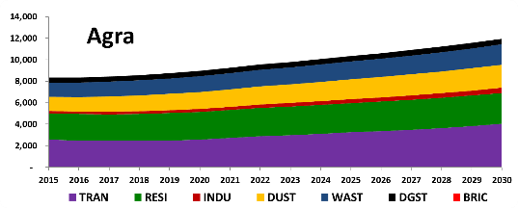 | 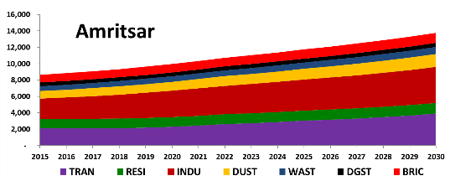 | 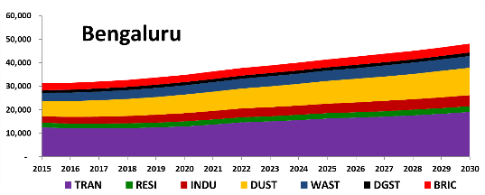 | 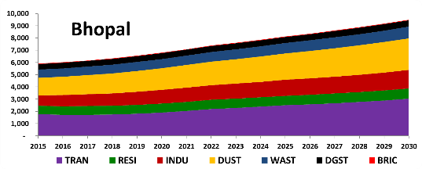
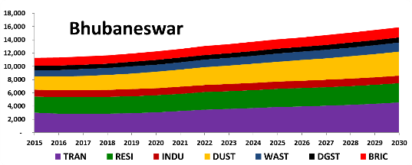 | 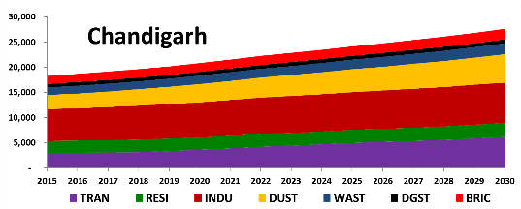 | 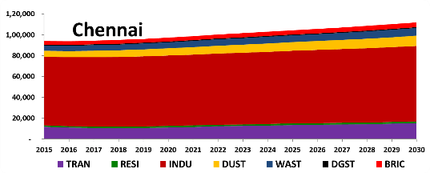 | 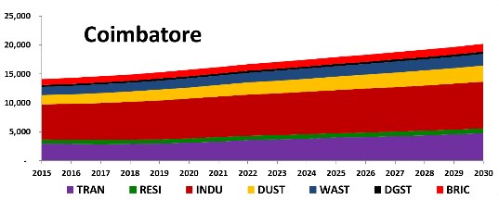
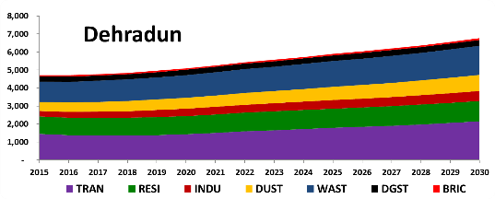 | 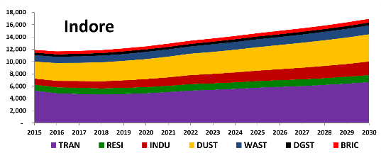 | 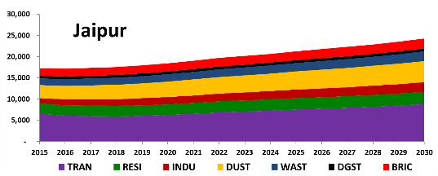 | 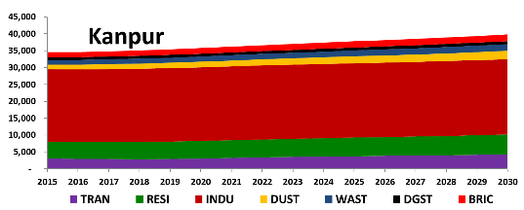
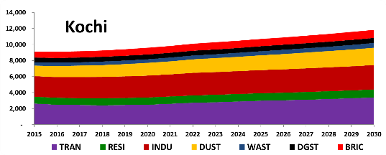 | 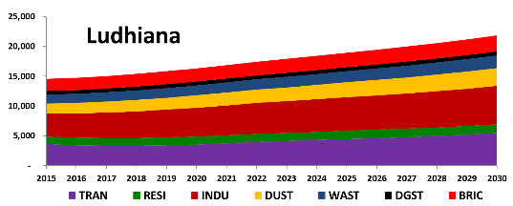 | 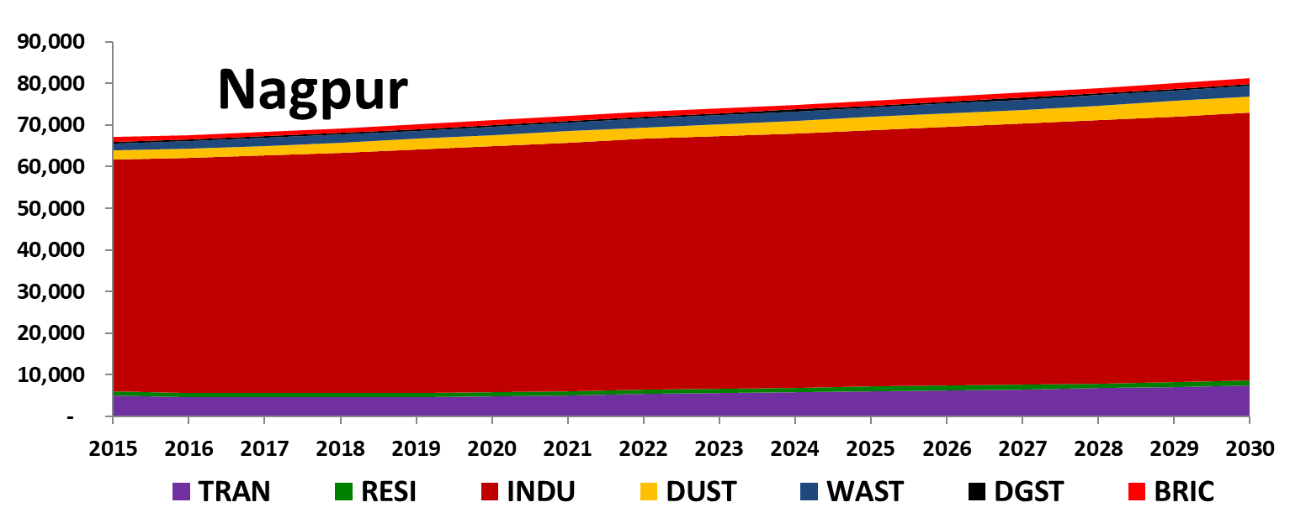 | 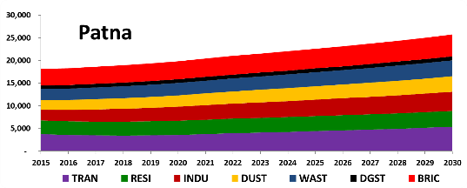
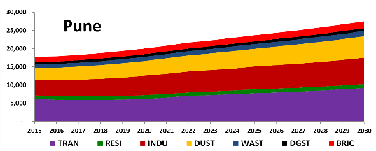 | 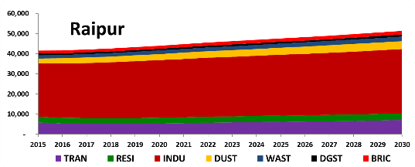 | 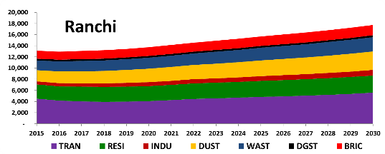 | 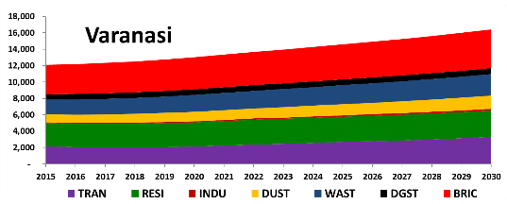

Figure: Estimated gridded annual PM_{2.5} emissions (in tons/year/grid) for 20 Indian cities in 2015
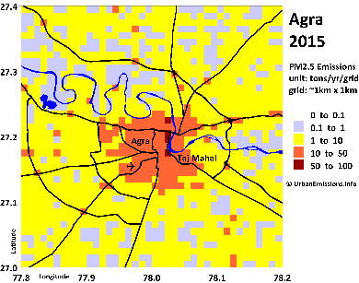 | 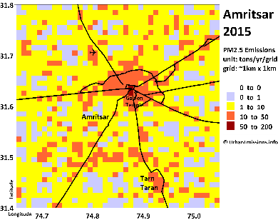 | 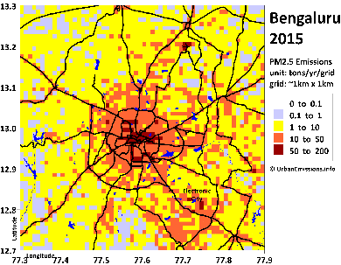 | 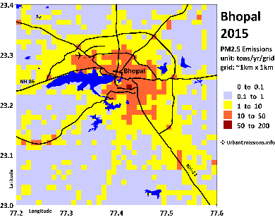 | 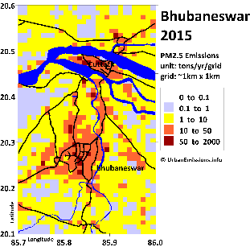
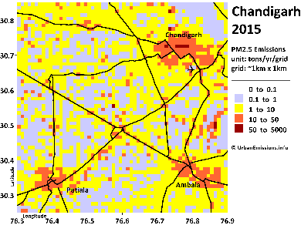 | 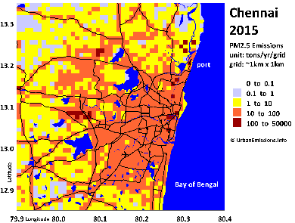 | 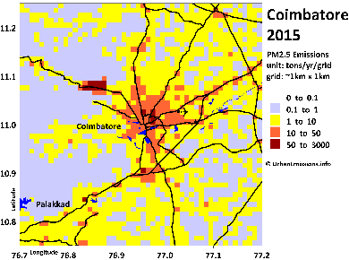 | 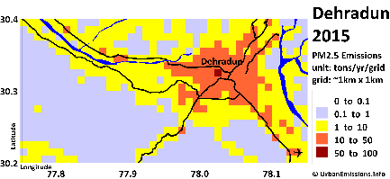 | 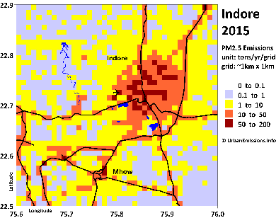
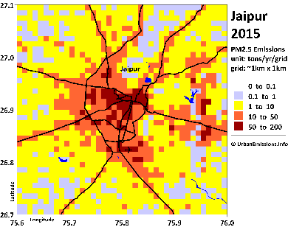 | 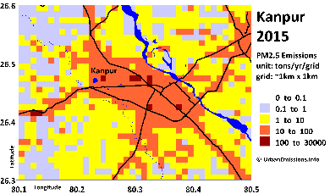 | 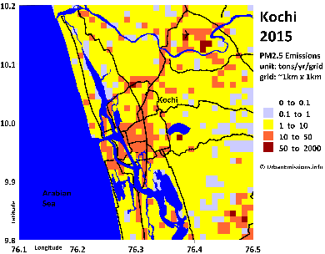 | 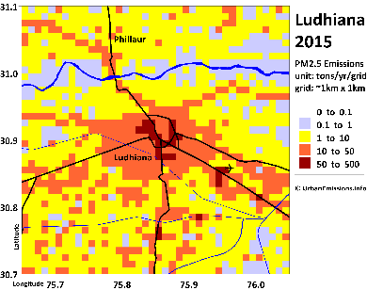 | 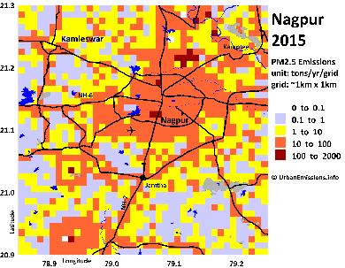
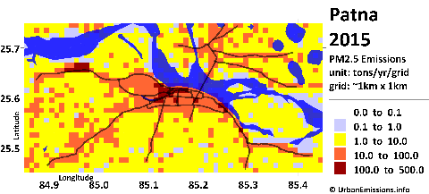 | 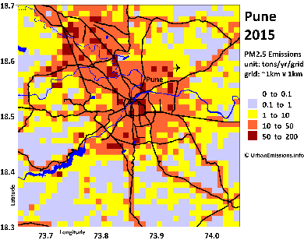 | 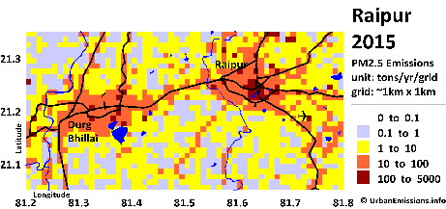 | 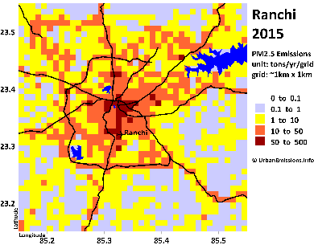 | 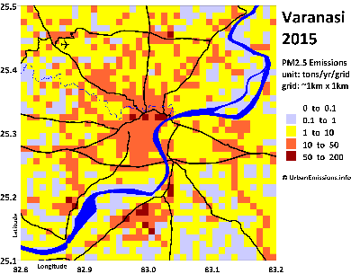

Figure 7: WRF-CAMx modeled annual average PM_{2.5} concentrations (in μg/m³) for 20 Indian cities in 2015 (in the figures, urban average = average of grids designated as urban)
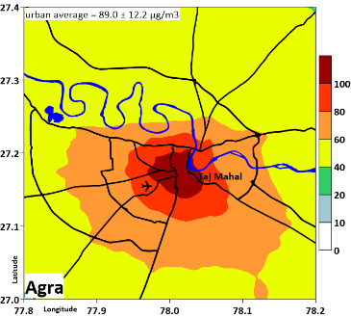 | 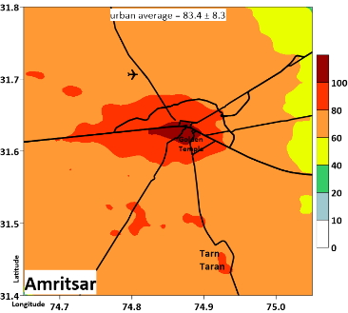 | 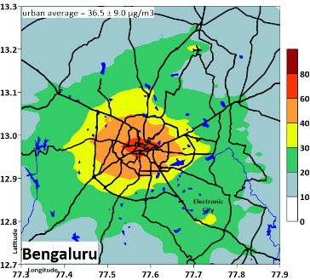 | 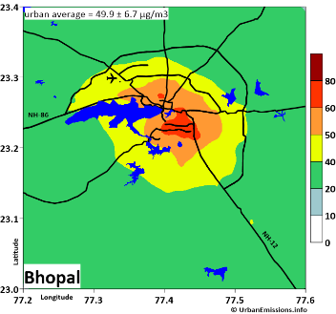 | 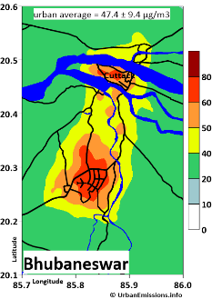
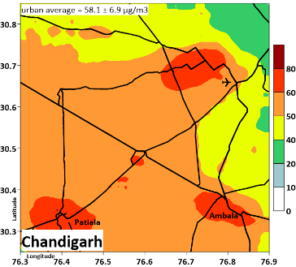 | 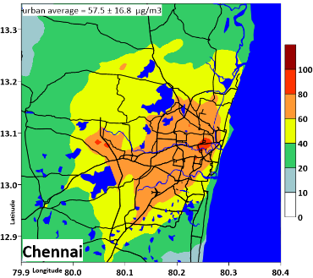 | 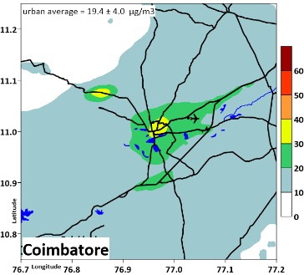 | 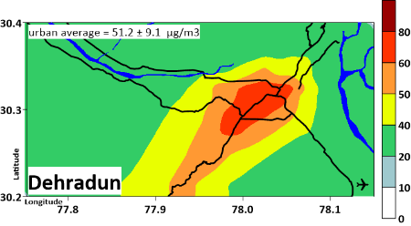 | 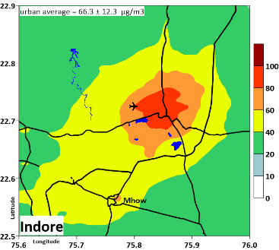
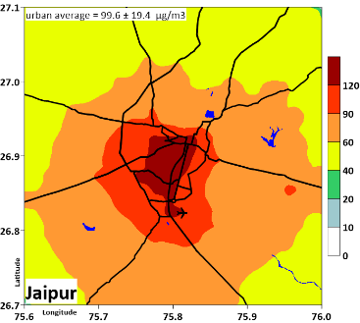 | 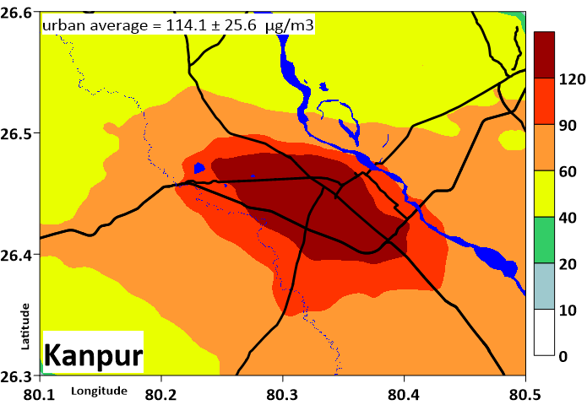 | 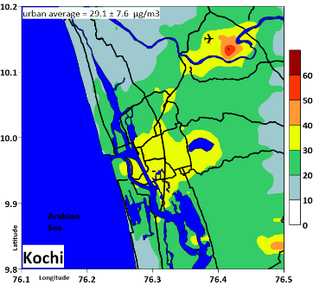 | 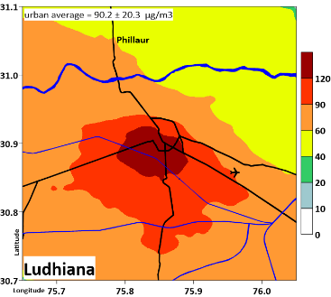 | 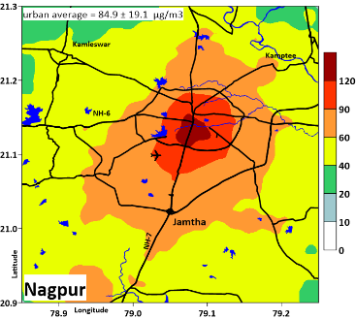
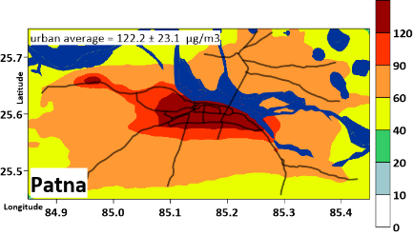 | 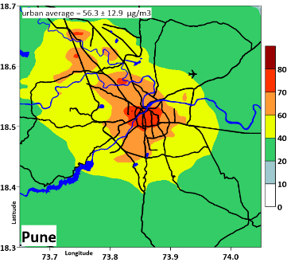 | 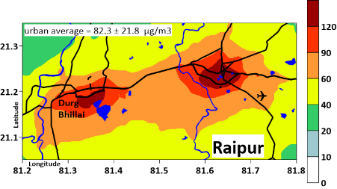 | 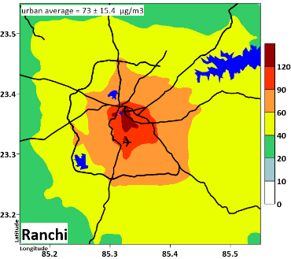 | 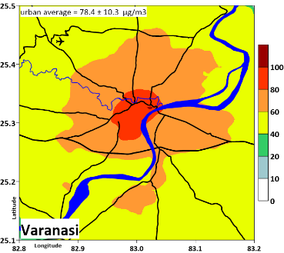

Figure 8: WRF-CAMx modeled monthly variation in PM_{2.5} concentrations (in μg/m³) for 20 Indian cities in 2015 (the shaded area corresponds to 5th and 95th percentile average of all the urban grids in the city airshed)
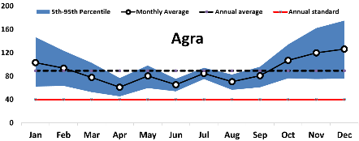 | 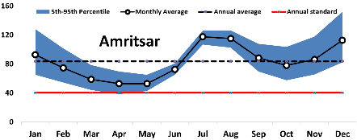 | 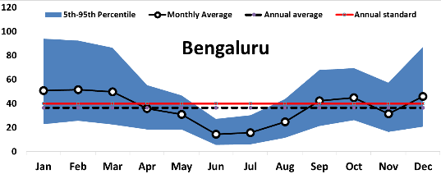 | 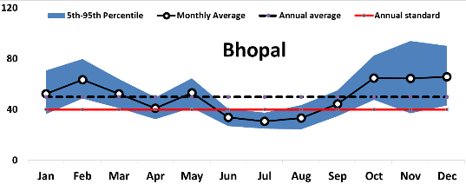
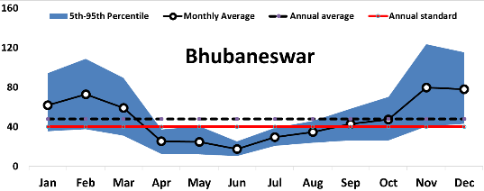 | 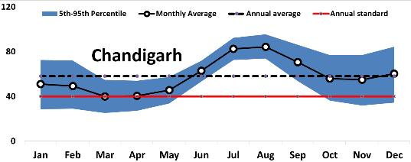 | 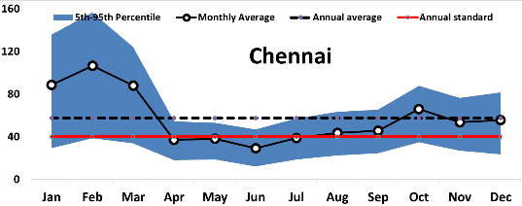 | 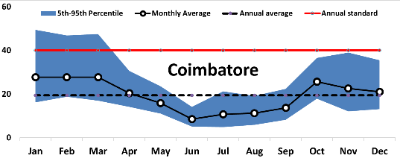
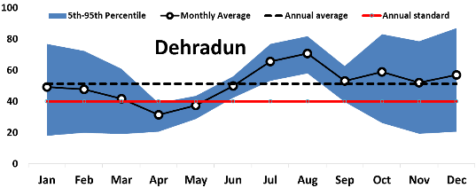 | 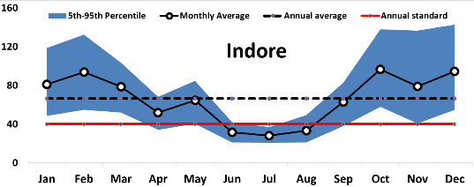 | 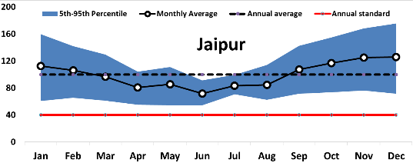 | 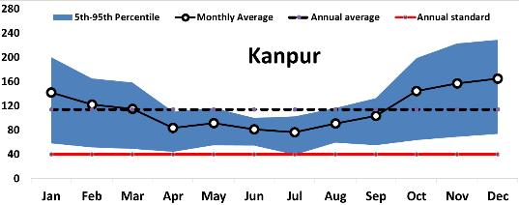
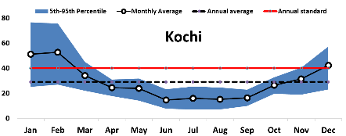 | 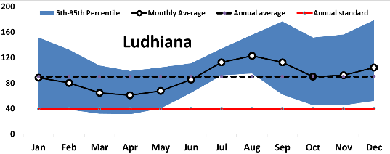 | 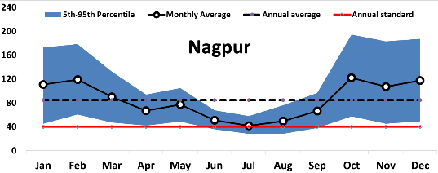 | 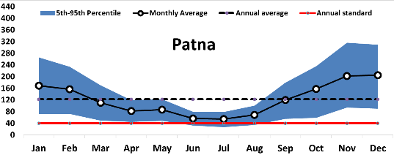
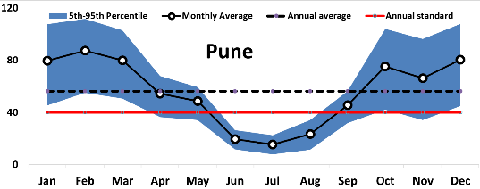 | 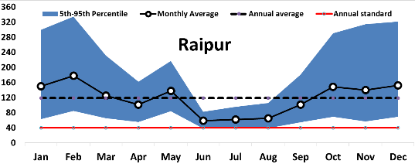 | 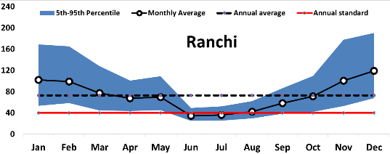 | 