Figure: WRF-CAMx modeled annual source contributions to PM_{2.5} concentrations (in μg/m³) for 20 Indian cities in 2015 (outside is the contribution of boundary conditions to the urban airshed, representing the influence of regional sources)
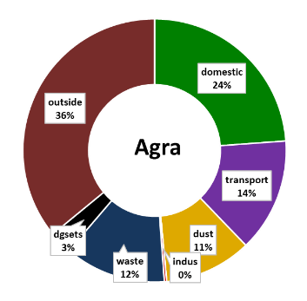 | 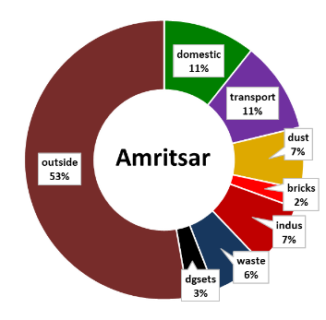 | 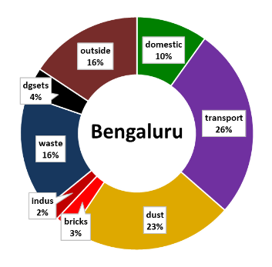 | 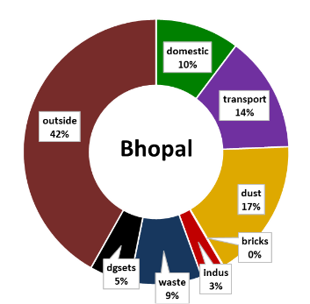 | 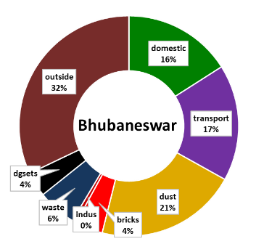
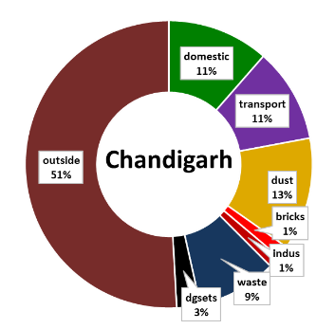 | 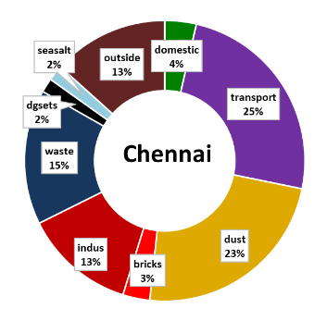 | 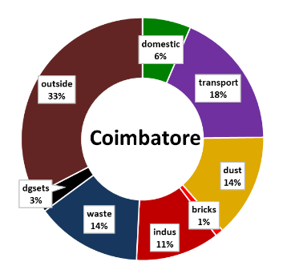 | 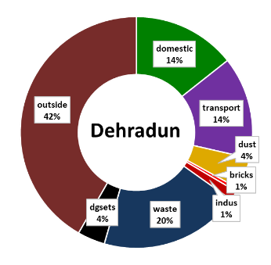 | 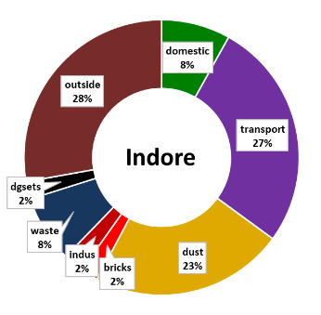
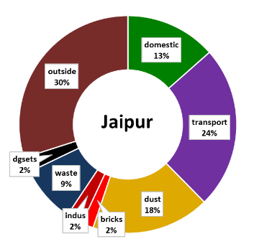 | 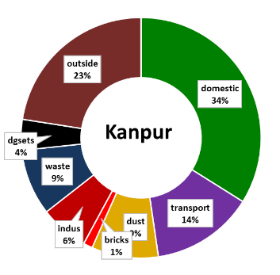 | 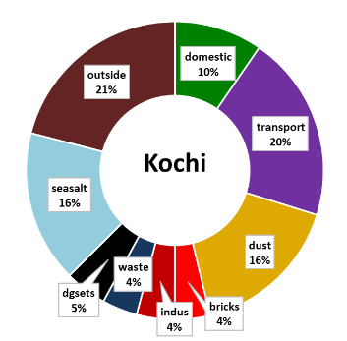 | 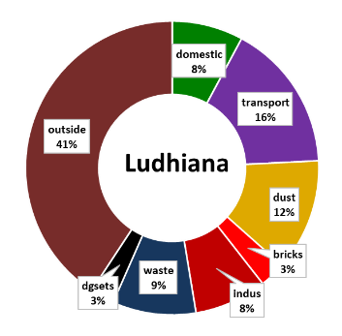 | 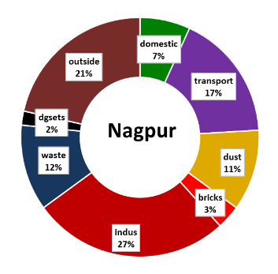
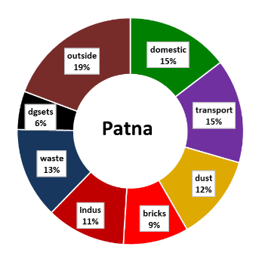 | 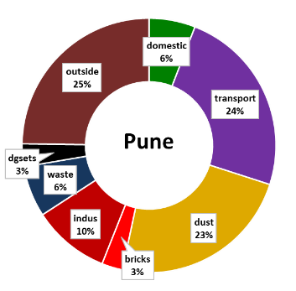 | 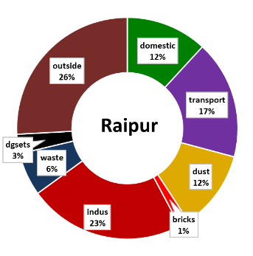 | 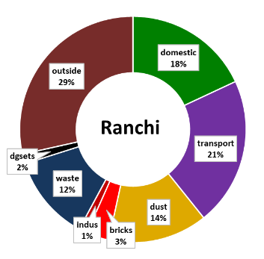 | 